Database design

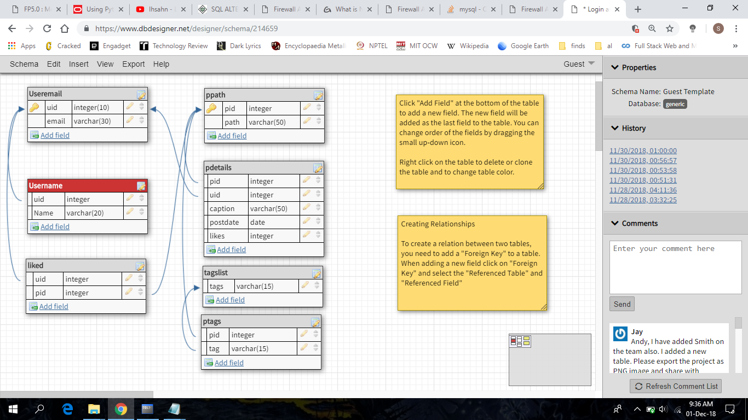

Table creation

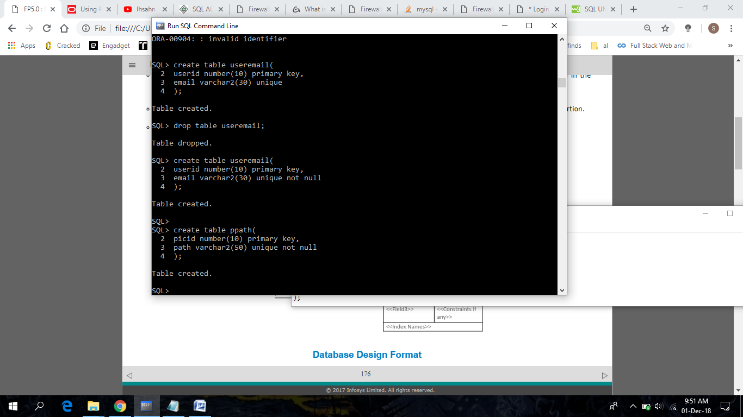

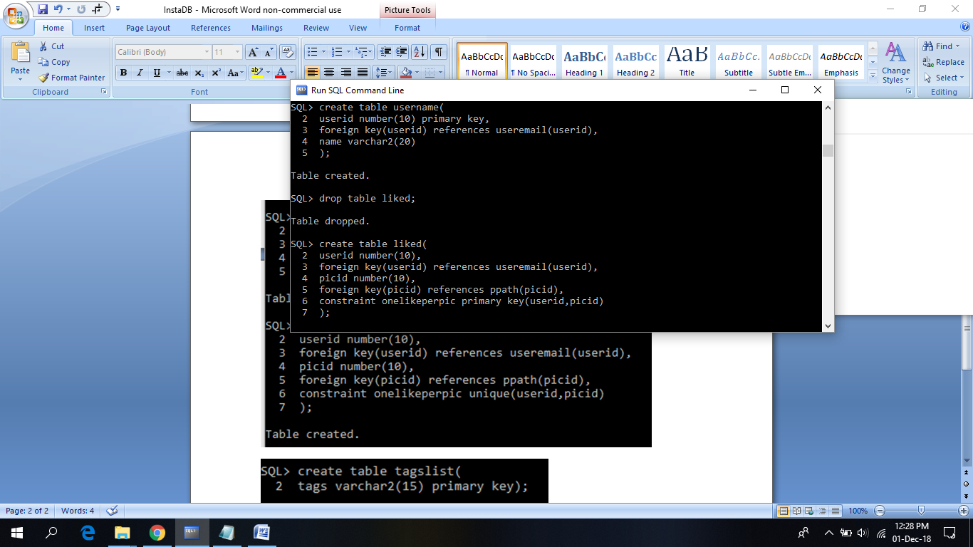



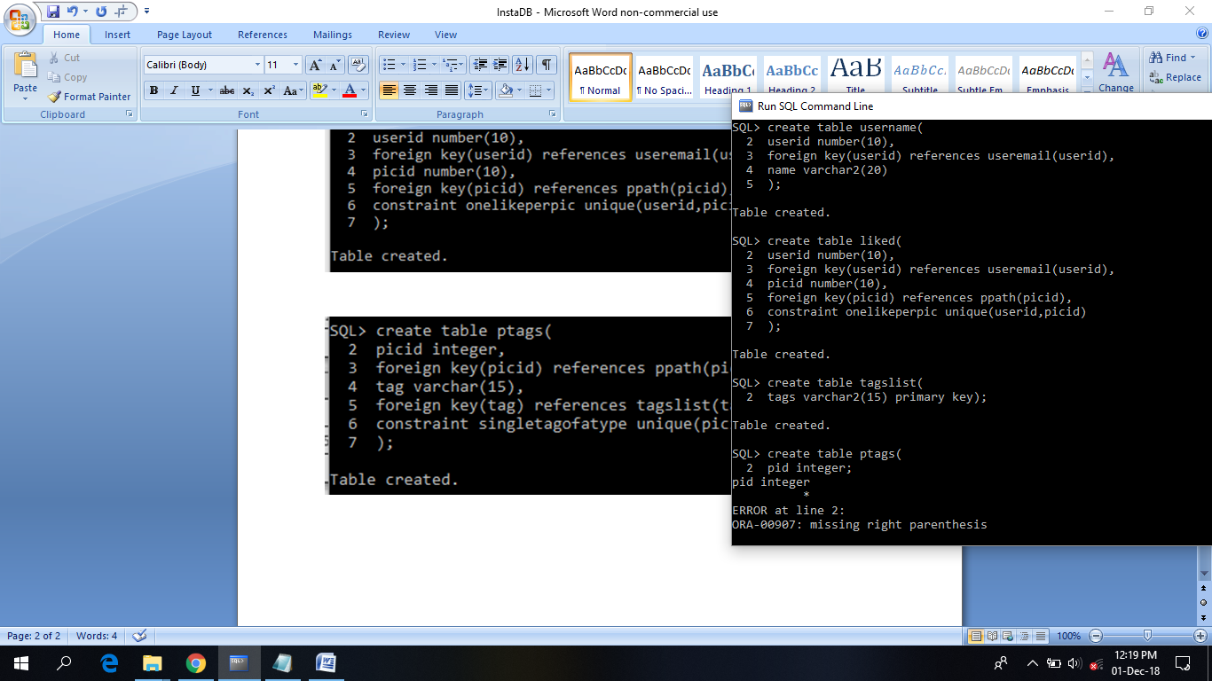

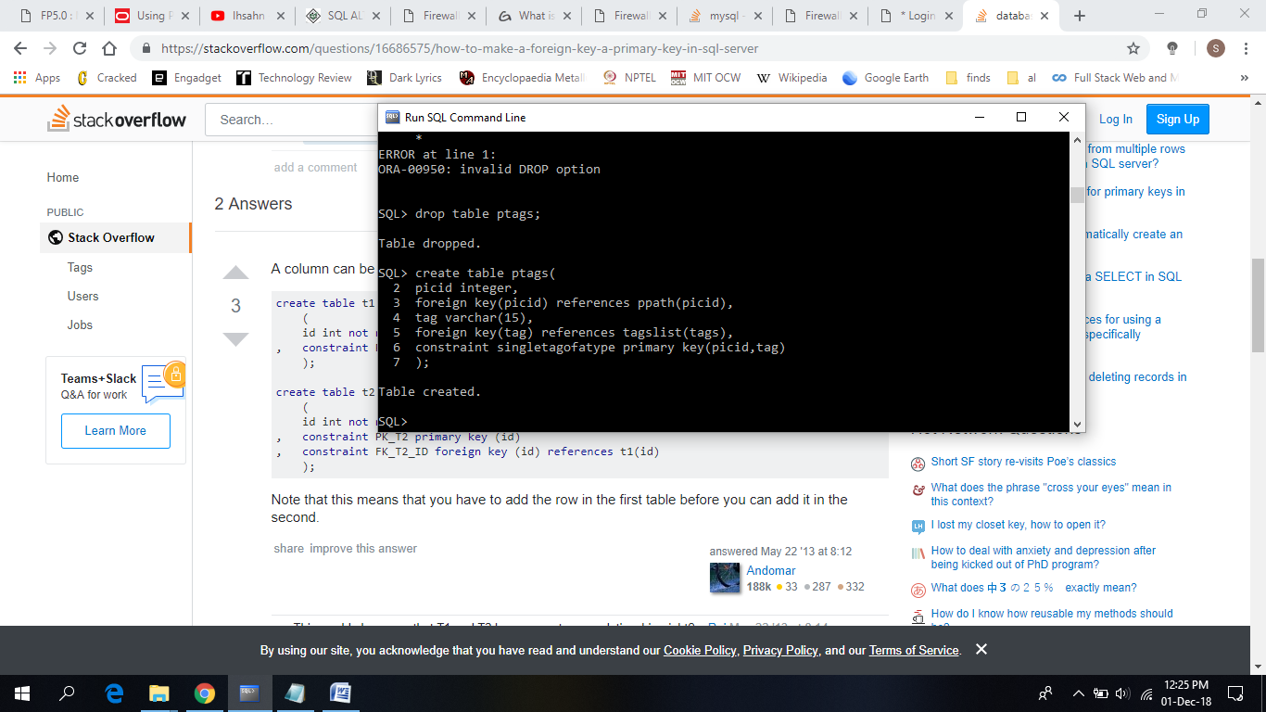

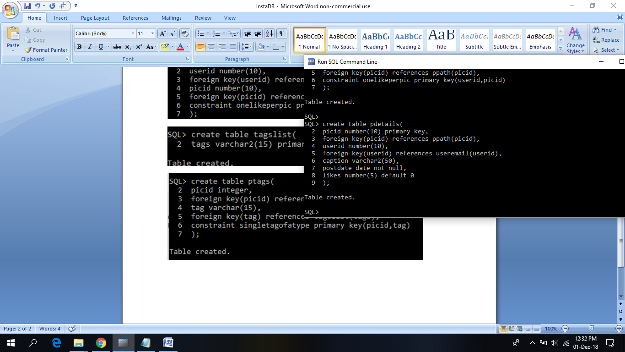

Insertion of data

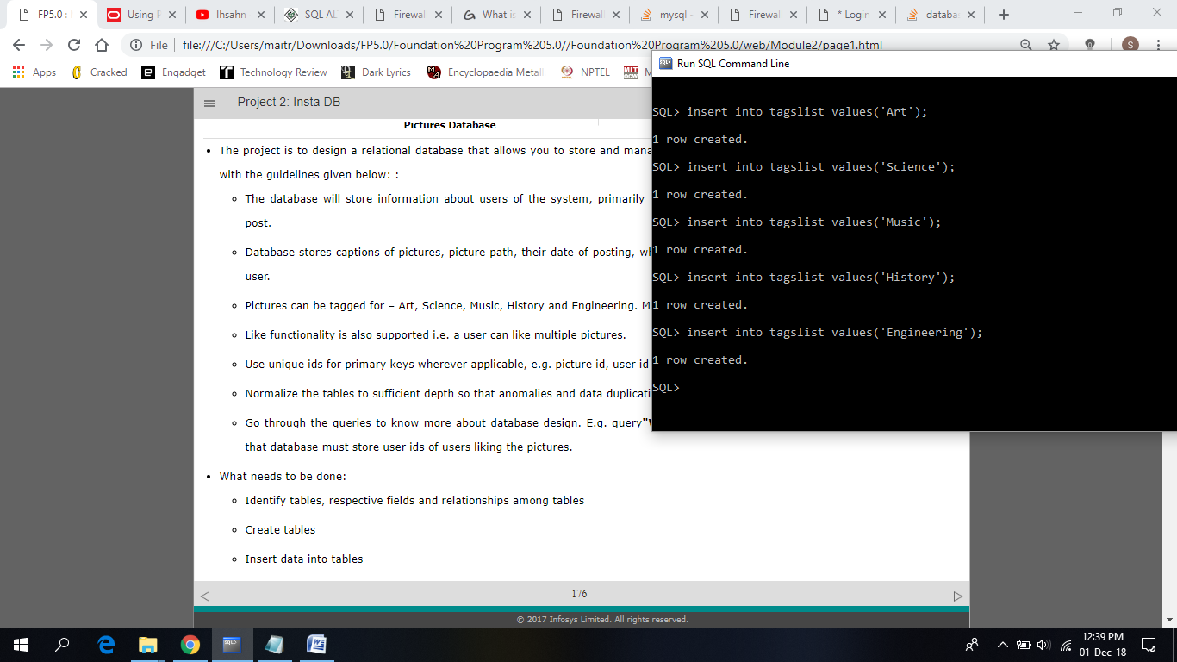

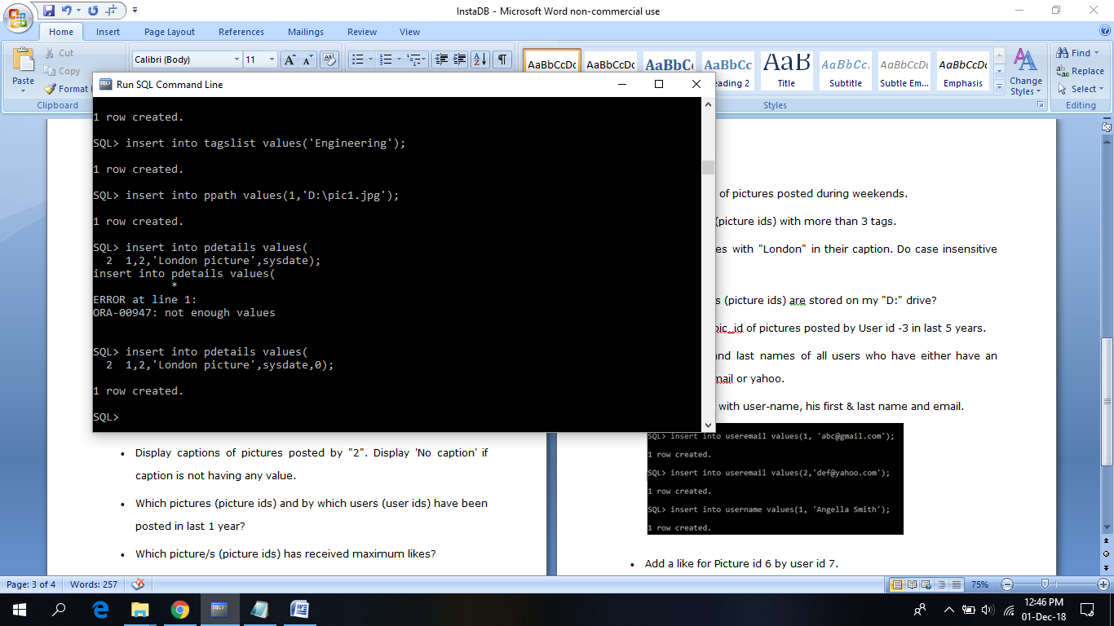



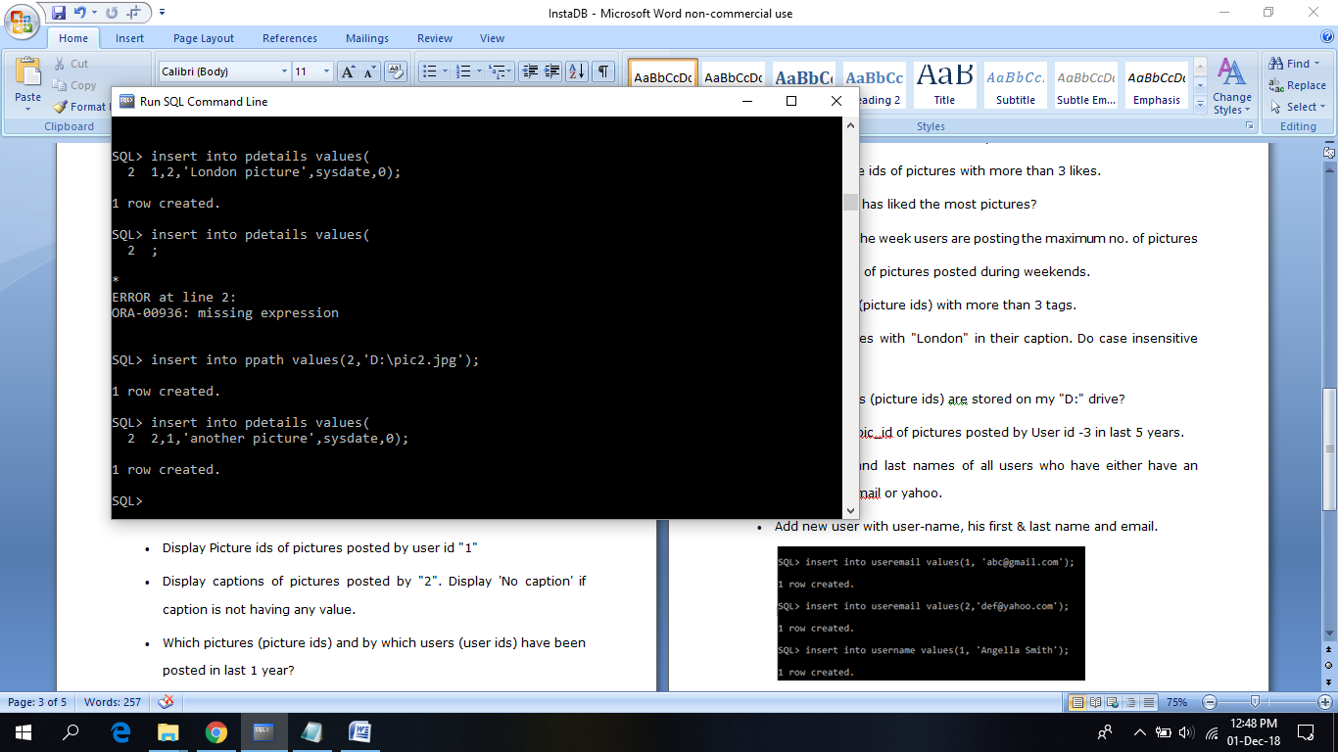



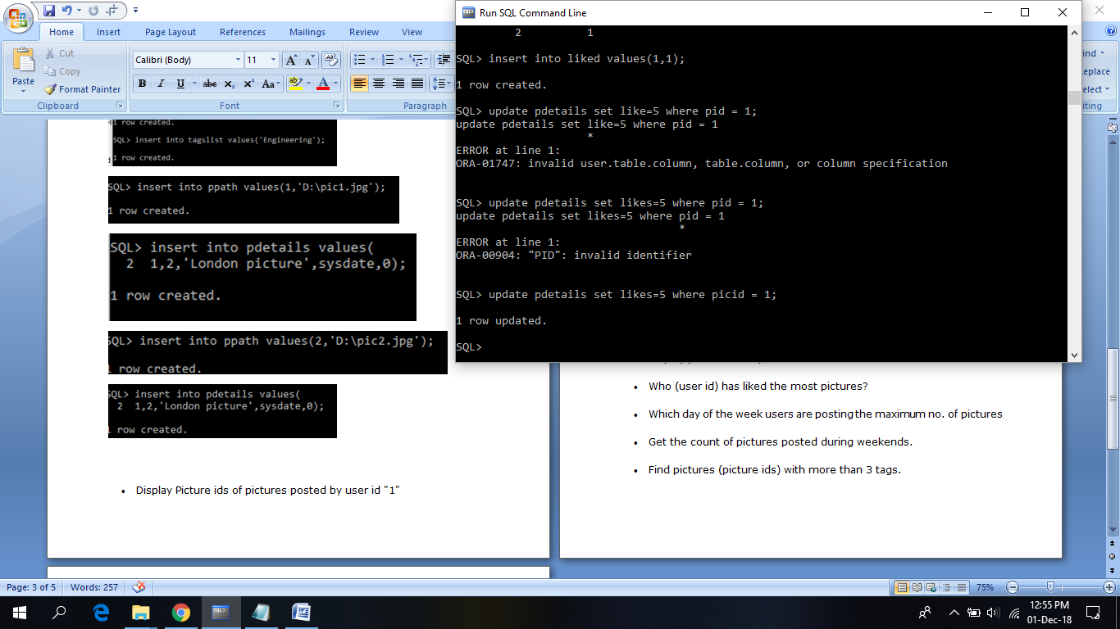



* Display Picture ids of pictures posted by user id "1"

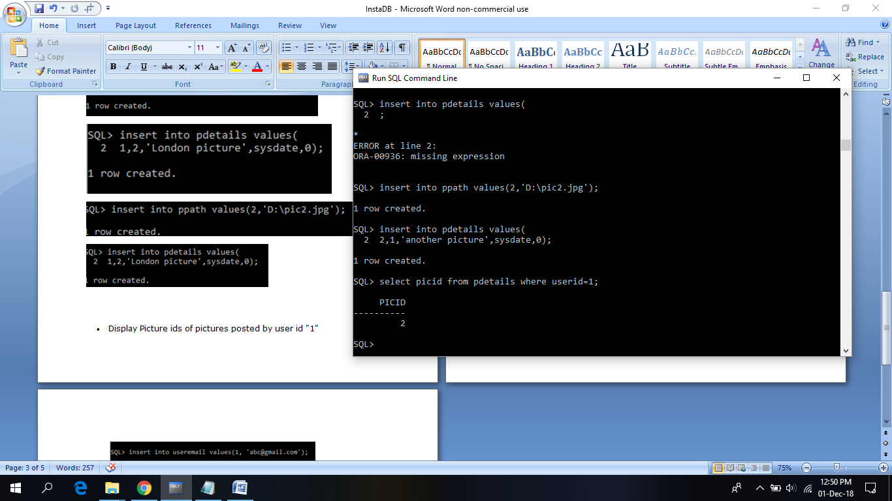

* Display captions of pictures posted by "2". Display 'No caption' if caption is not having any value.
* Which pictures (picture ids) and by which users (user ids) have been posted in last 1 year?

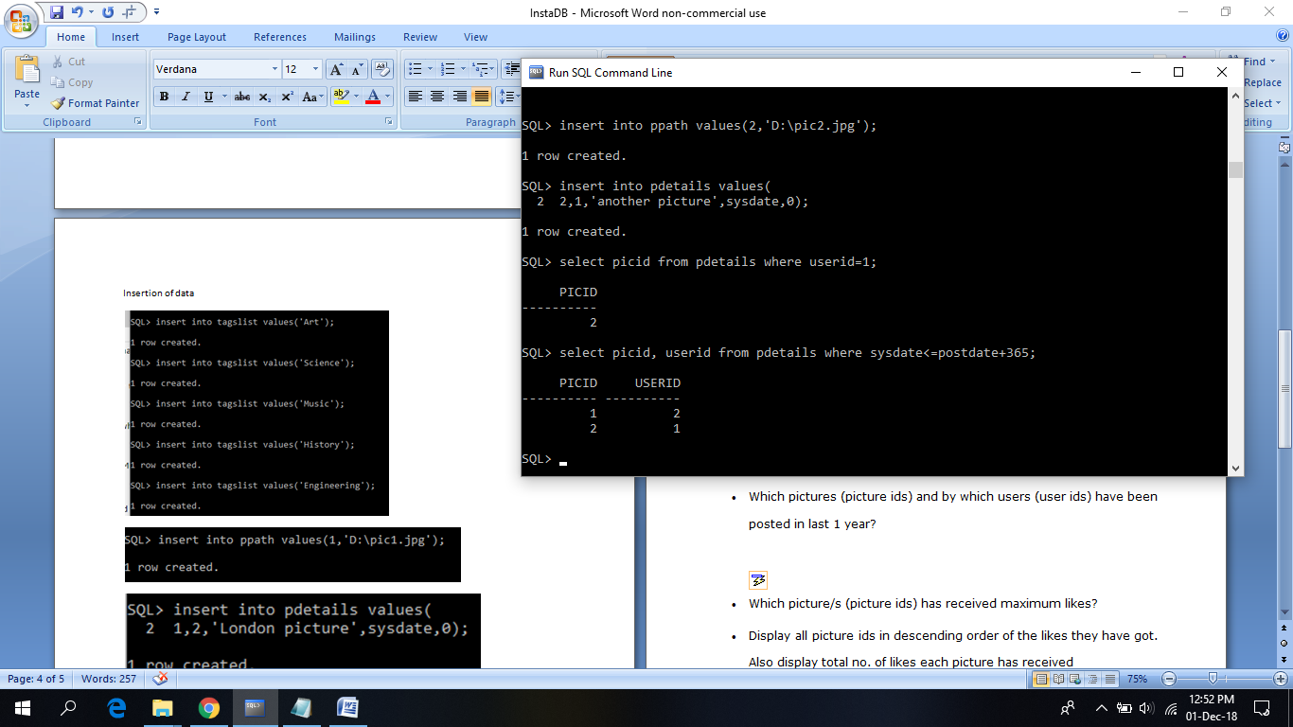

* Which picture/s (picture ids) has received maximum likes?

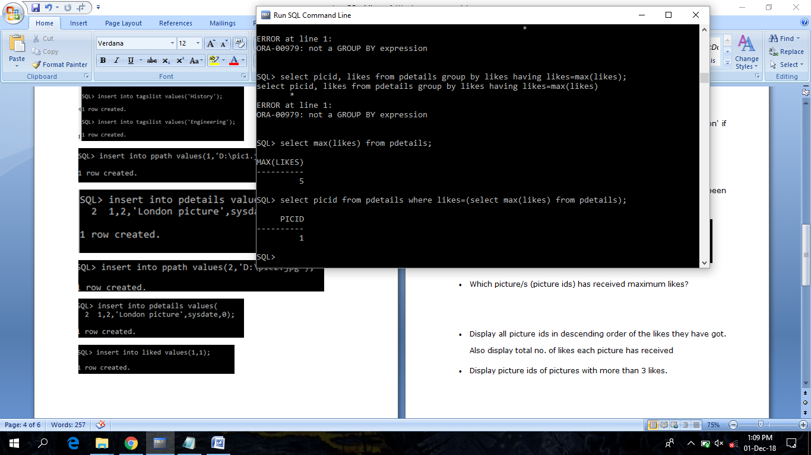

* Display all picture ids in descending order of the likes they have got. Also display total no. of likes each picture has received

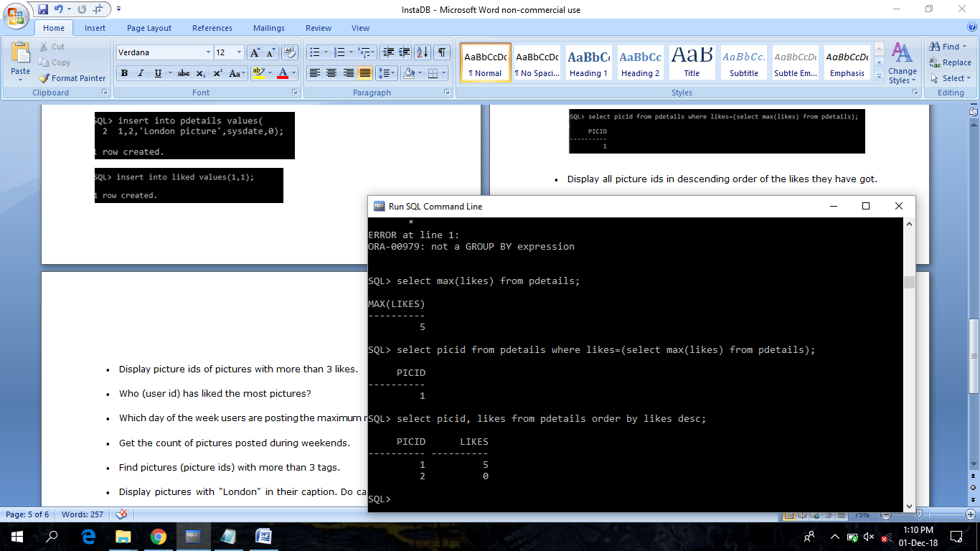

* Display picture ids of pictures with more than 3 likes.

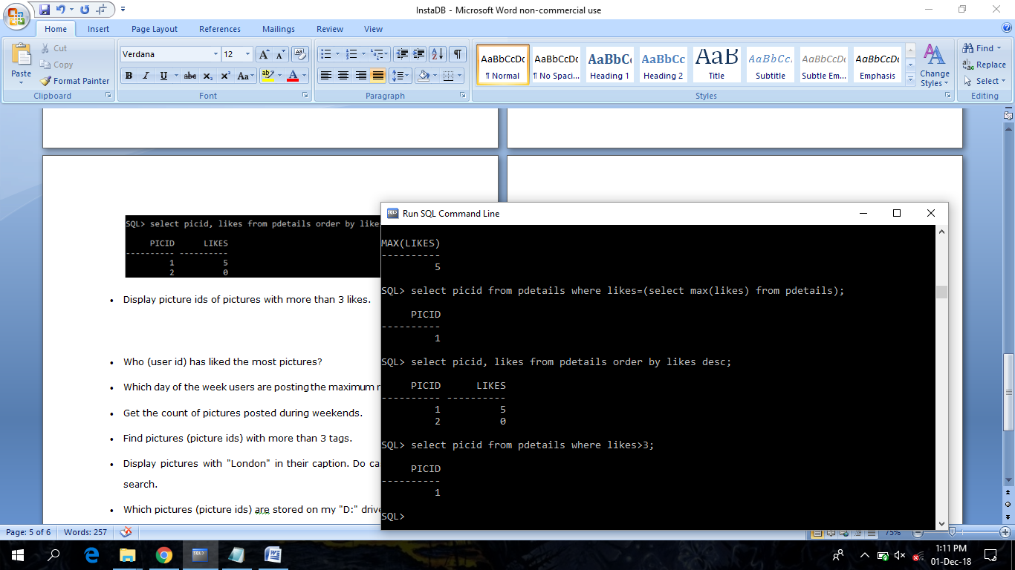

* Who (user id) has liked the most pictures?

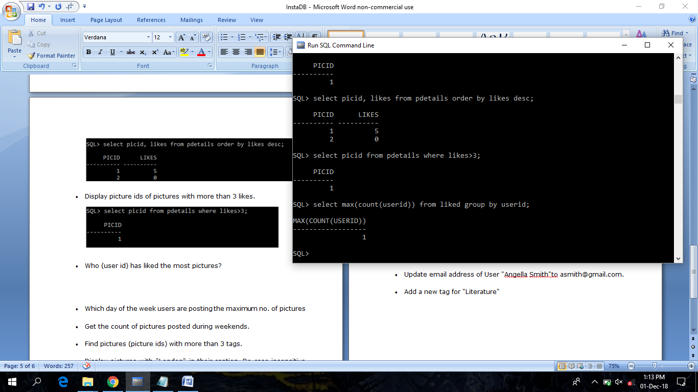

* Which day of the week users are posting the maximum no. of pictures

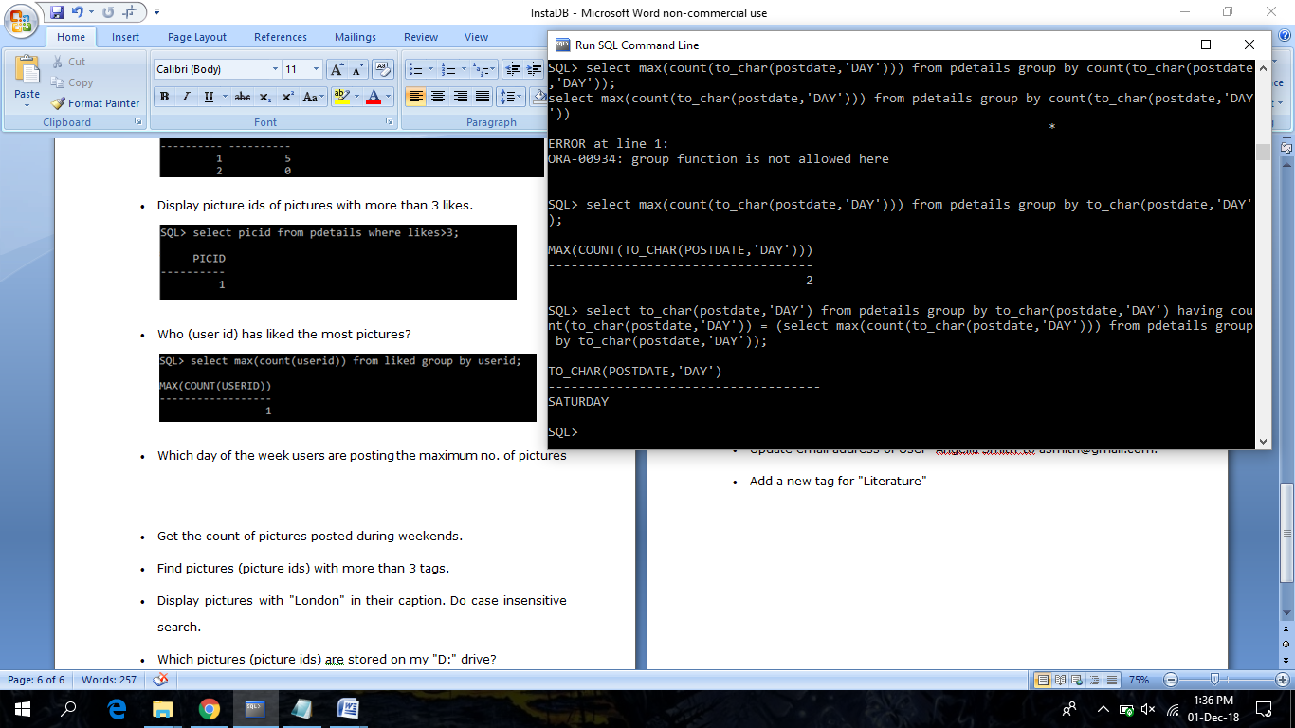

* Get the count of pictures posted during weekends.

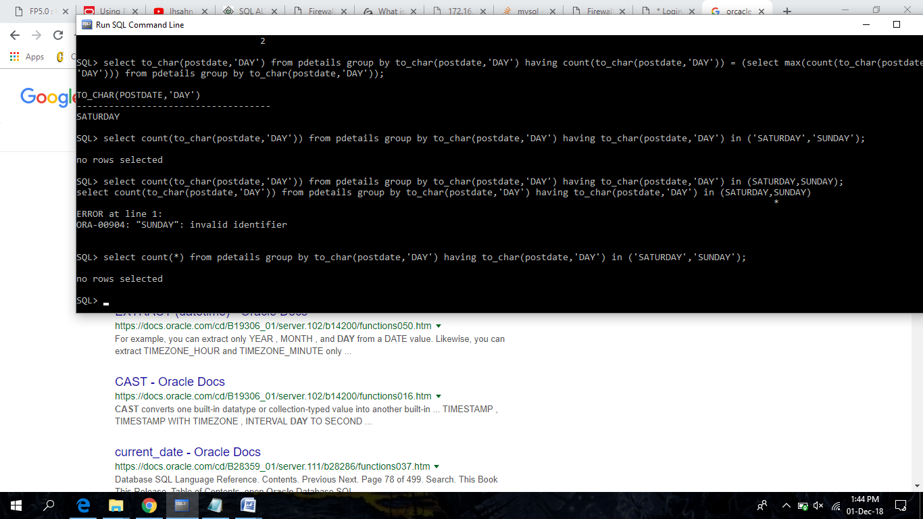

* Find pictures (picture ids) with more than 3 tags.

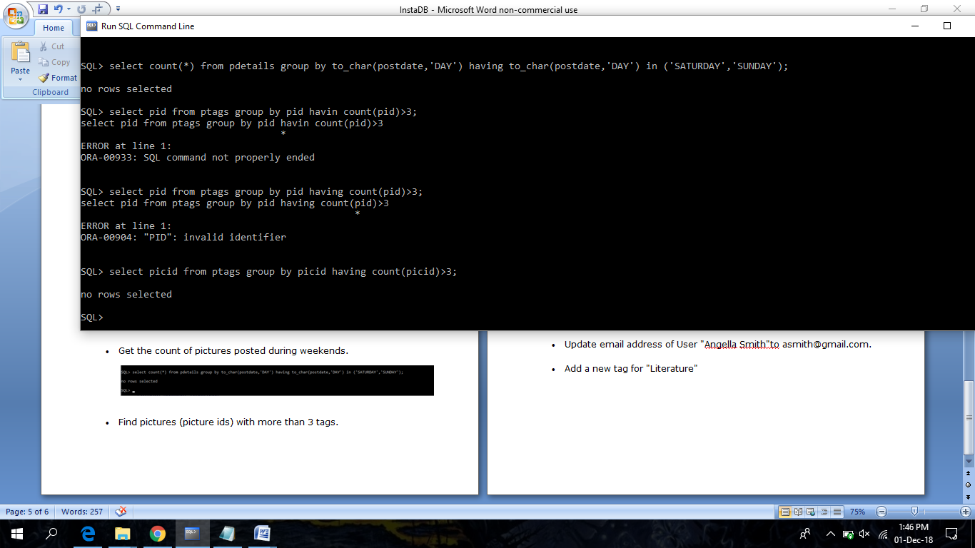

* Display pictures with "London" in their caption. Do case insensitive search.

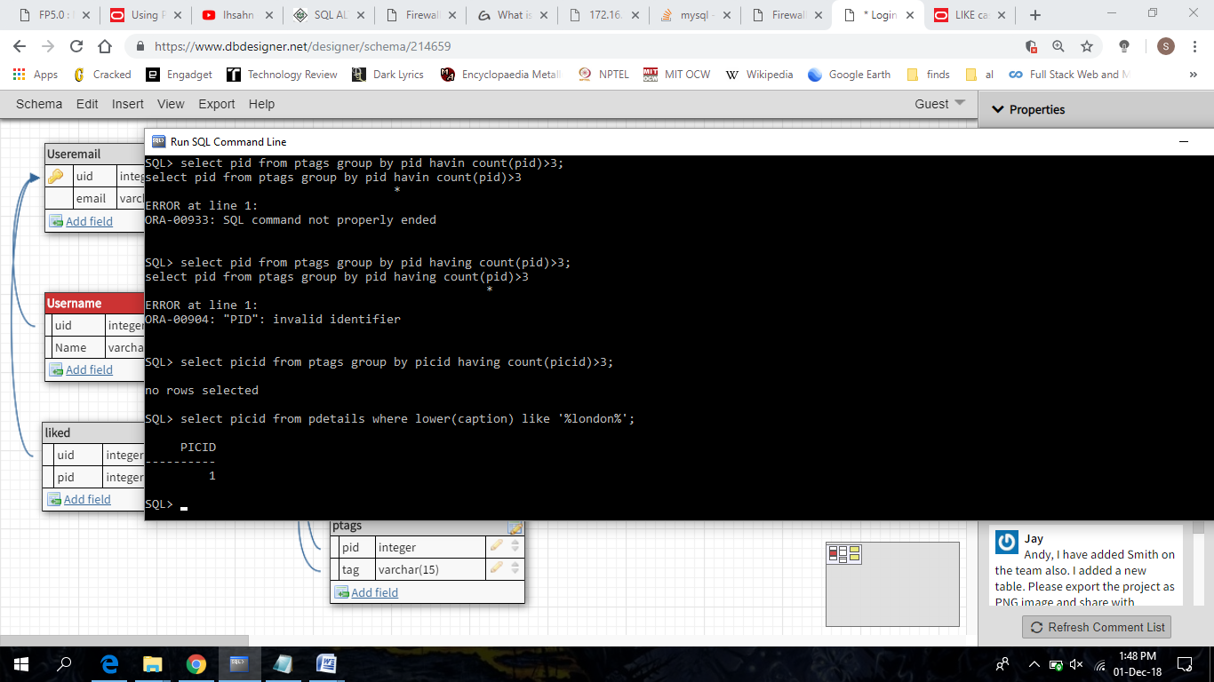

* Which pictures (picture ids) are stored on my "D:" drive?

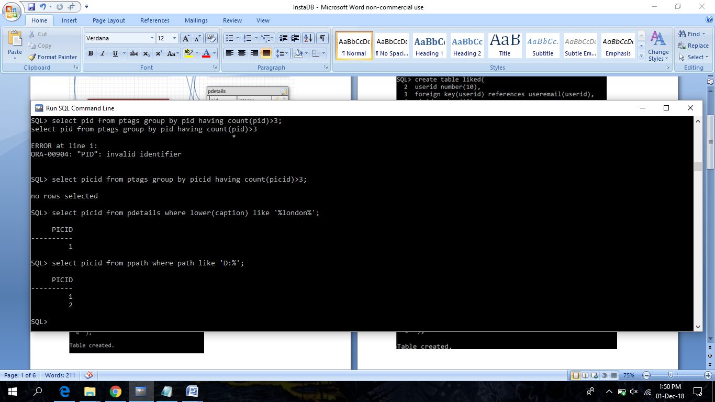

* Display first and last names of all users who have either have an account on gmail or yahoo.

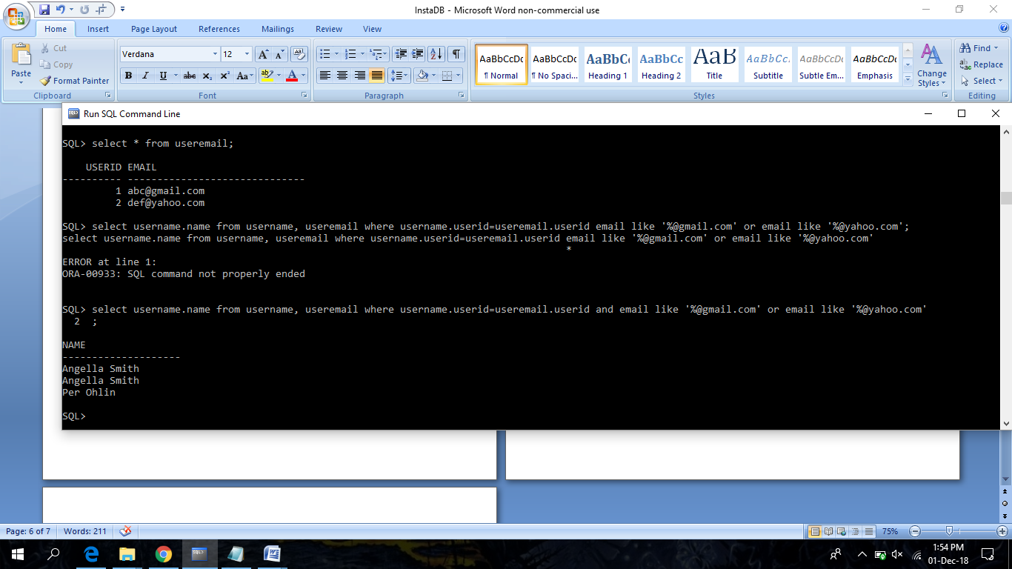

* Add new user with user-name, his first & last name and email.

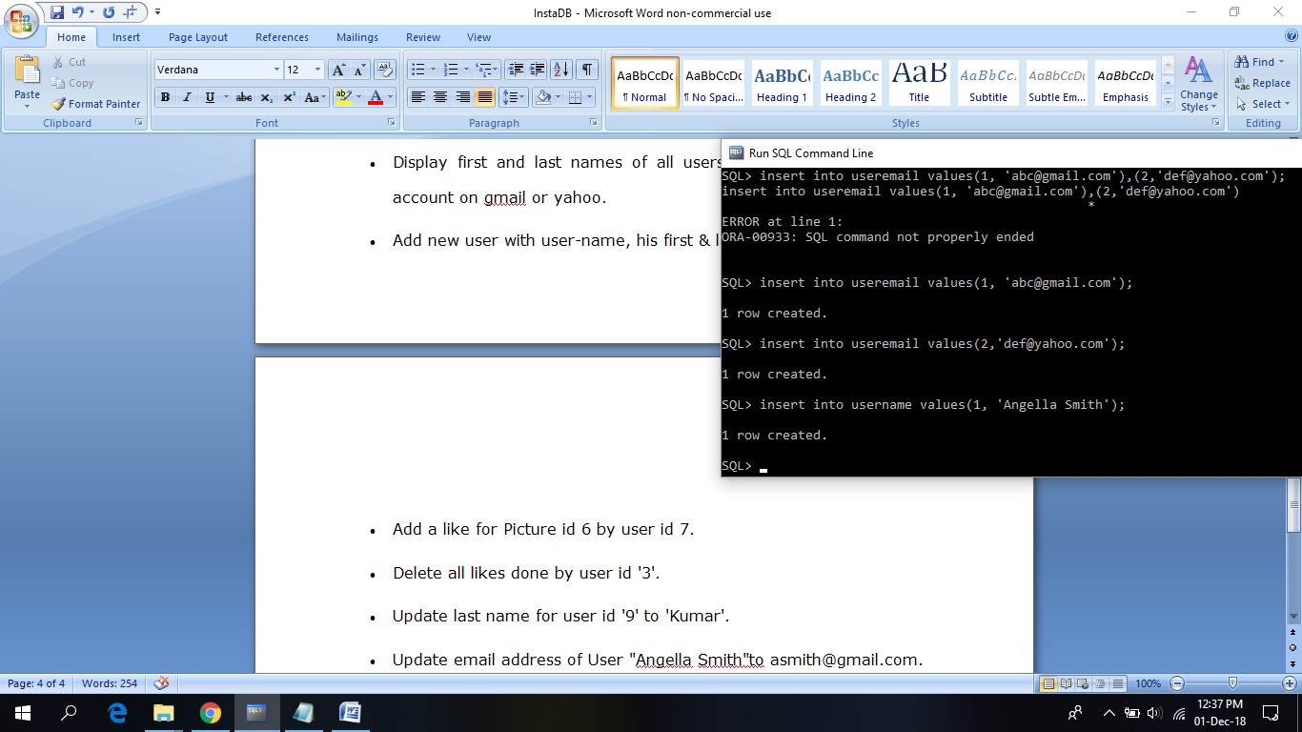

* Add a new tag for "Literature"

